Qwallity app

Jemma Mkrtchyan

**Application for testing:** [**https://exam-qwallity.herokuapp.com/**](https://exam-qwallity.herokuapp.com/)

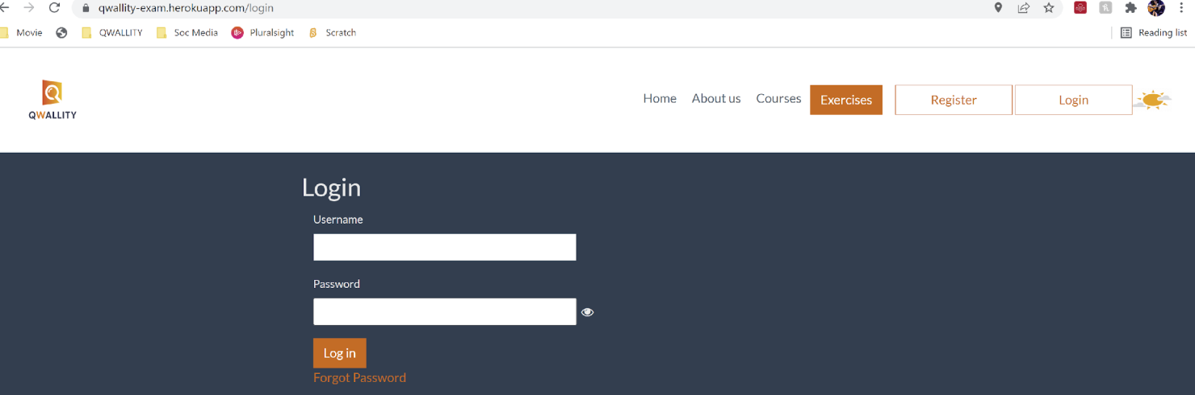This application is used to add and view courses details, buy, edit and delete them.

There is an opportunity to buy course via discount.

**Requirement**

As an admin user I can configure discount for courses from my account.

As a non admin user I can buy course with discount configured by admin.

**Acceptance Criteria**

Admin user navigate to his/her profile. Change Discount button is visible. Change discount screen contains

* **Course Type** ddl with **Advanced** and **Fundamental** options
* **discount** which is numeric
* **course_count** field which is numeric
* **Change Discount button**, after submission admin see notification – ‘Discount changes’

Non admin user login to the system, buy Fundamental and Advanced courses. *Price should be shown already discounted(take into account admin configuration).* Notification- ’*You have xxx discount. Discounted price displays.’*

Requirement clarifications questions

**Find below a list of requirement clarification questions regarding an opportunity to buy courses on discount:**

1. The criteria of the discount and course_count fields are not completely and precisely formulated (for example, it's not specified how many input values should be accepted)

2. The names of course_count, discount field and course type do not match each other.

3. After discount submission the admin sees "discount changes", instead it should be "discount is changed".

4. According to the criteria mentioned in the requirement, the non-admin user should receive the following notification: "You have xxx discount. The discounted price is displayed”.

**Suggestions**

* "Change discount" submission button can be replaced by “submit”.
* The "discount" field can be made into drop down list, which will allow to select the amount of defined discount.
* After purchasing the discounted course, it is desirable for the non-admin user to see the initial price of the course in addition to the discounted price.

Bug report #1

|  |  |
| --- | --- |
| ID number | #1 |
| Bug Summary | When we set discount with valid inputs, we saw different submission messages. |
| Reporter | Jemma Mkrtchyan |
| Submit Date | 13/10/2022 |
| Platform | Microsoft Windows |
| Operating System | Windows 7 |
| Browser | Google Chrome |
| Severity | Low |
| Priority |  |
| Status |  |
| Assigned to | Ani Movsisyan |
| Version |  |
| Environment | dev, uat |

**Steps to reproduce**

1. Go to Qwallity app.
2. Input the email and code: manualtesting07152022@gmail.com and 619649157.
3. Click “Send” button.
4. Click “Login” button.
5. Input the admin username (JemmaMK) and password: (grigor90),
6. Click “Login” button.
7. Click button which named “JemmaMk”.
8. Click “Change Discount” button.
9. Input numbers in the “discount” field.
10. Select “Course Type”
11. Click “Change discount” button.

**Expected result**

After submission we should see notification saying “Discount changes”.

**Actual result**

After submission we see notification saying “Discount is changed”.

Bug report #2

|  |  |
| --- | --- |
| ID number | #2 |
| Bug Summary | When we set alphabetical inputs in ‘discount’ field, we don’t see error message. |
| Reporter | Jemma Mkrtchyan |
| Submit Date | 13/10/2022 |
| Platform | Microsoft Windows |
| Operating System | Windows 7 |
| Browser | Google Chrome |
| Severity | Critical |
| Priority |  |
| Status |  |
| Assigned to | Ani Movsisyan |
| Version |  |
| Environment | dev, uat |

**Steps to reproduce**

1. Go to Qwallity app.
2. Input the email and code: manualtesting07152022@gmail.com and 619649157.
3. Click “Send” button.
4. Click “Login” button.
5. Input the admin username (JemmaMK)and password: (grigor90),
6. Click “Login” button.
7. Click button which named “JemmaMk”.
8. Click “Change Discount” button.
9. Input alphabetical characters in the “discount” field.
10. Select “Course Type”.
11. Click “Change discount” button.

**Expected result**

There should be an error message saying “Please input only numerical characters under “discount” field.

**Actual result**

When we set alphabetical inputs in ‘discount’ field, we see “Discount is changed” message.

Bug report #3

|  |  |
| --- | --- |
| ID number | #3 |
| Bug Summary | When we set alphabetical inputs in ‘course_count’ field, we don’t see error message. |
| Reporter | Jemma Mkrtchyan |
| Submit Date | 13/10/2022 |
| Platform | Microsoft Windows |
| Operating System | Windows 7 |
| Browser | Google Chrome |
| Severity | Critical |
| Priority |  |
| Status |  |
| Assigned to | Ani Movsisyan |
| Version |  |
| Environment | dev, uat |

**Steps to reproduce**

1. Go to Qwallity app.
2. Input the email and code: manualtesting07152022@gmail.com and 619649157.
3. Click “Send” button.
4. Click “Login” button.
5. Input the admin username (JemmaMK)and password: (grigor90),
6. Click “Login” button.
7. Click button which named “JemmaMk”.
8. Click “Change Discount” button.
9. Input alphabetical characters in the “course_count” field.
10. Select “Course Type”

**Expected result**

There should be an error message saying “Please input only numerical characters under “course_count” field.

**Actual result**

When we set alphabetical inputs in ‘course_count’ field, we see “Discount is changed” message.

Bug report #4

|  |  |
| --- | --- |
| ID number | #4 |
| Bug Summary | When we clicking “change discount” with empty “discount” and “course_count” fields, we don’t see error messages under the fields. |
| Reporter | Jemma Mkrtchyan |
| Submit Date | 13/10/2022 |
| Platform | Microsoft Windows |
| Operating System | Windows 7 |
| Browser | Google Chrome |
| Severity | Low |
| Priority |  |
| Status |  |
| Assigned to | Ani Movsisyan |
| Version |  |
| Environment | dev, uat |

**Steps to reproduce**

1. Go to Qwallity app.
2. Input the email and code: manualtesting07152022@gmail.com and 619649157.
3. Click “Send” button.
4. Click “Login” button.
5. Input the admin username (JemmaMK)and password: (grigor90),
6. Click “Login” button.
7. Click button which named “JemmaMk”.
8. Click “Change Discount” button.
9. Don’t input anything in the “discount” and “course_count” fields.
10. Select “Course Type”
11. Click “change discount” button.

**Expected result**

There should be an error message like “Field is required” under the “discount” and “course_count” fields.

**Actual result**

When we click “change discount” with empty “discount” and “course_count” fields we don’t see error message under the fields.

Bug report #5

|  |  |
| --- | --- |
| ID number | #5 |
| Bug Summary | “course_count” function is not working |
| Reporter | Jemma Mkrtchyan |
| Submit Date | 13/10/2022 |
| Platform | Microsoft Windows |
| Operating System | Windows 7 |
| Browser | Google Chrome |
| Severity | Critical |
| Priority |  |
| Status |  |
| Assigned to | Ani Movsisyan |
| Version |  |
| Environment | dev, uat |

**Steps to reproduce**

1. Go to Qwallity app.
2. Input the email and code: manualtesting07152022@gmail.com and 619649157.
3. Click “Send” button.
4. Click “Login” button.
5. Input the admin username (JemmaMK)and password: (grigor90),
6. Click “Login” button.
7. Click button which named “JemmaMk”.
8. Click “Change Discount” button.
9. Input 10 in the “discount”
10. Input 3 in the “course_count” field.
11. Select “Course Type”
12. Click “change discount” button.

**Expected result**

After purchasing the 3rd course, the 4th course should be discounted by 10%.

**Actual result**

The course is discounted by 10% since the first purchase.

Bug report #6

|  |  |
| --- | --- |
| ID number | #6 |
| Bug Summary | When non admin user buys fundamental or advanced course they get wrong notification. |
| Reporter | Jemma Mkrtchyan |
| Submit Date | 13/10/2022 |
| Platform | Microsoft Windows |
| Operating System | Windows 7 |
| Browser | Google Chrome |
| Severity | Low |
| Priority |  |
| Status |  |
| Assigned to | Ani Movsisyan |
| Version |  |
| Environment | dev, uat |

**Steps to reproduce**

1. Go to Qwallity app.
2. Input the email and code: manualtesting07152022@gmail.com and 619649157.
3. Click “Send” button.
4. Click “Login” button.
5. Input the admin username (JemmaMK)and password: (grigor90),
6. Click “Login” button.
7. Click button which named “JemmaMk”.
8. Click “Change Discount” button.
9. Input 10 in the “discount”
10. Input 3 in the “course_count” field.
11. Select “Course Type”
12. Click “change discount” button.

**Expected result**

Non admin user should see notification “You have xxx discount. Discounted price displays”.

**Actual result**

Non admin user get wrong notification like “You have xxx discount. Discounted price is displayed”.